

1. Ready position:

Feet shoulder width apart and knees slightly bent.

4. Move your hands towards the object to catch.

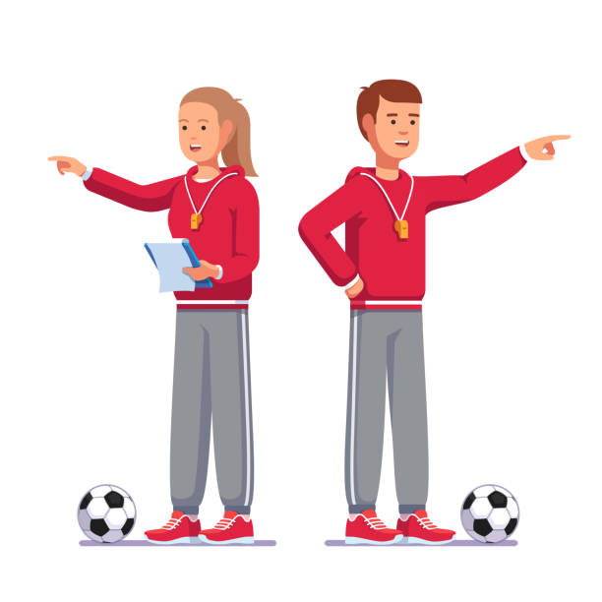

6. Soft hands and once caught, bring the object into your body.

5. Grip the object with your fingers as it lands into your hands.

3. Hands make an appropriate target, with little fingers glued together and remaining fingers spread.

2. Eyes focussed on the object.