20 Books to Read
Before you Leave YR
Here’s a list of books to try and read in Reception. Your challenge is to try and read half of them before the end of the year (if you’ve already read them, you can tick them off, but they don’t count towards this year!)
The first 2 rows are books you may read as part of your curriculum, so please only read them when your teacher gives them to you or after the term it is used! The other 2 rows are a mixture of genres, themes and classic or modern stories. Try to mix up your choices and then post a review on your class’s reading blog. Every half term the best reviews will win a prize!

Guided Reading | We’re Going on a Bear Hunt  by Michael Rosen | Stick Man  by Julia Donaldson | Supertato  by SueHendra | Dear Zoo  by Rod Campbell | Brown bear, brown bear, what do you see? By Bill Martin Jr
 | 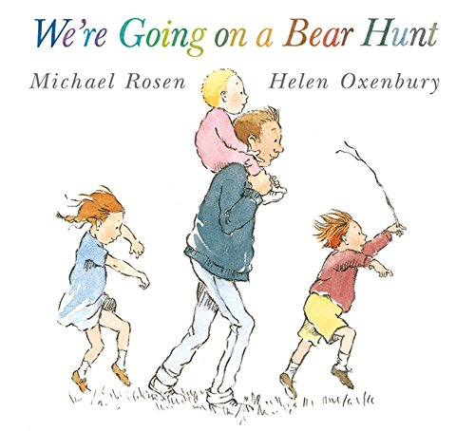 | 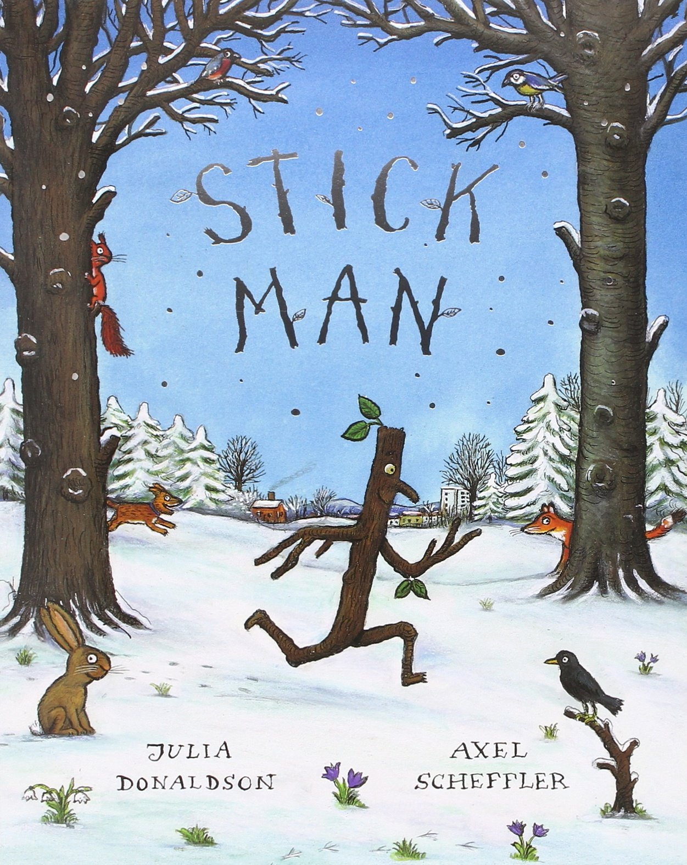 | 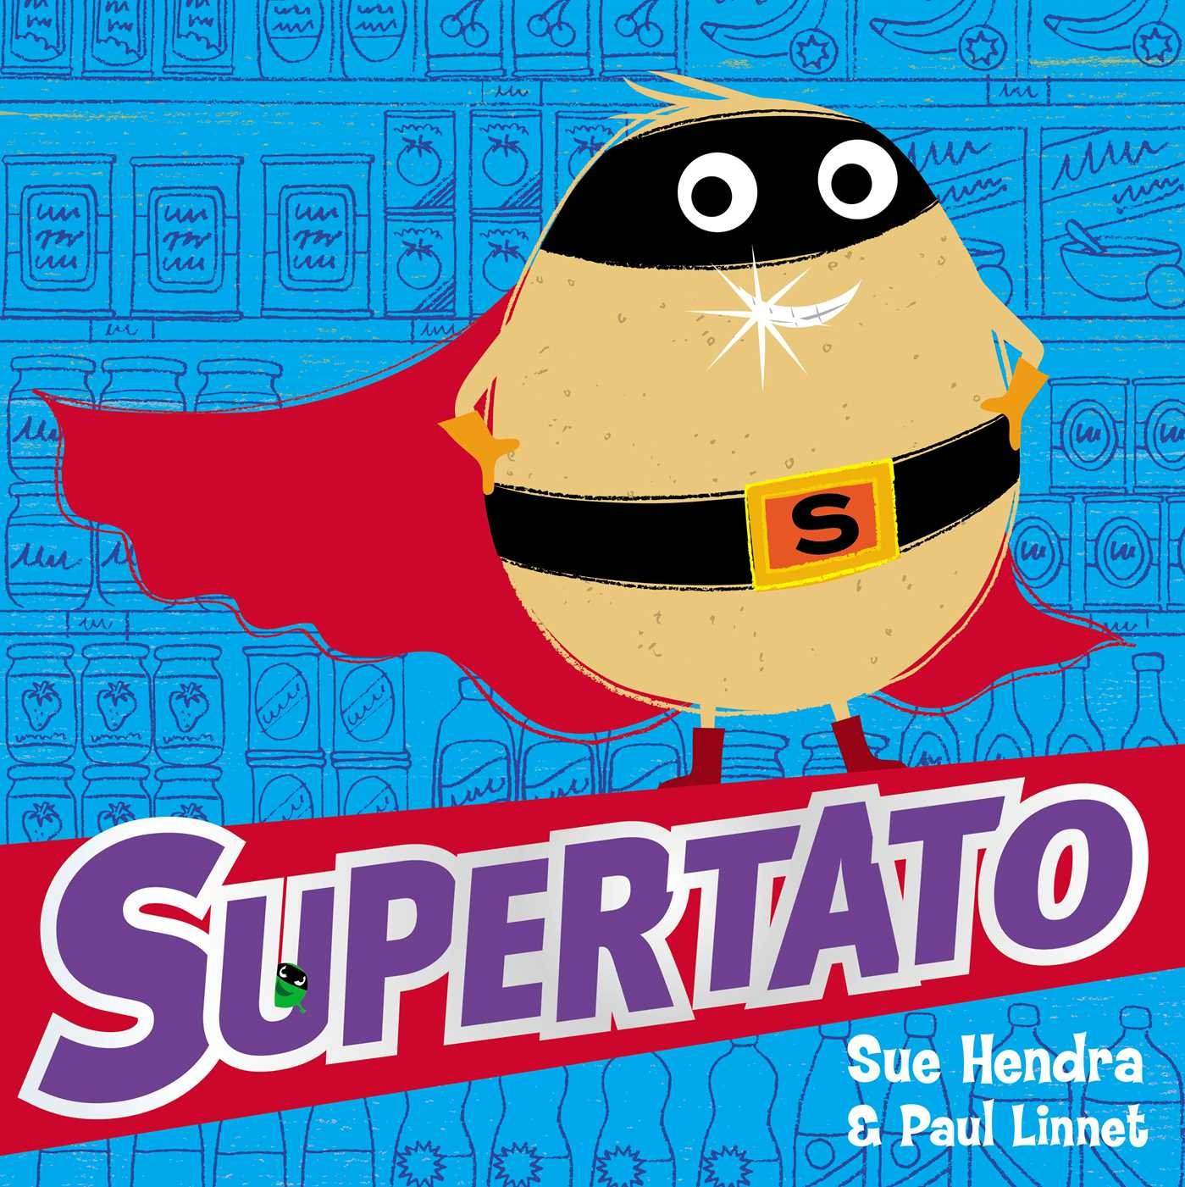 | 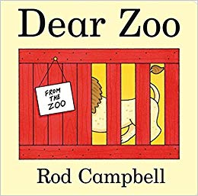 | 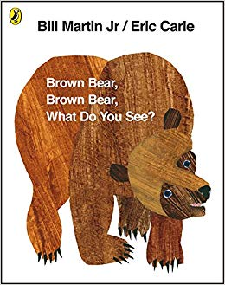
 | I Read/Read to Me: | I Read/Read to Me: | I Read/Read to Me: | I Read/Read to Me: | I Read/Read to Me:
 | Understanding the World | Understanding the World | Understanding the World | Understanding the World
 | Tadpoles Promise  by Jeanne Willis | Jaspers Beanstalk  by Nick Butterworth | Room on the broom  by Julia Donaldson | Elmer  by David Mckee | Ten Little Fingers and Ten Little Toes by Mem Fox
 | 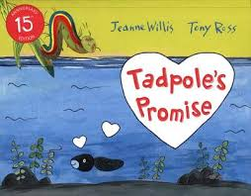 | 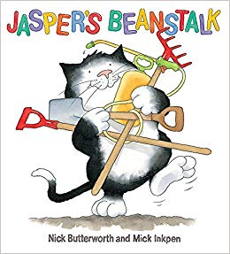 | 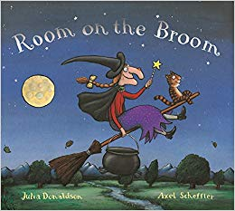 | 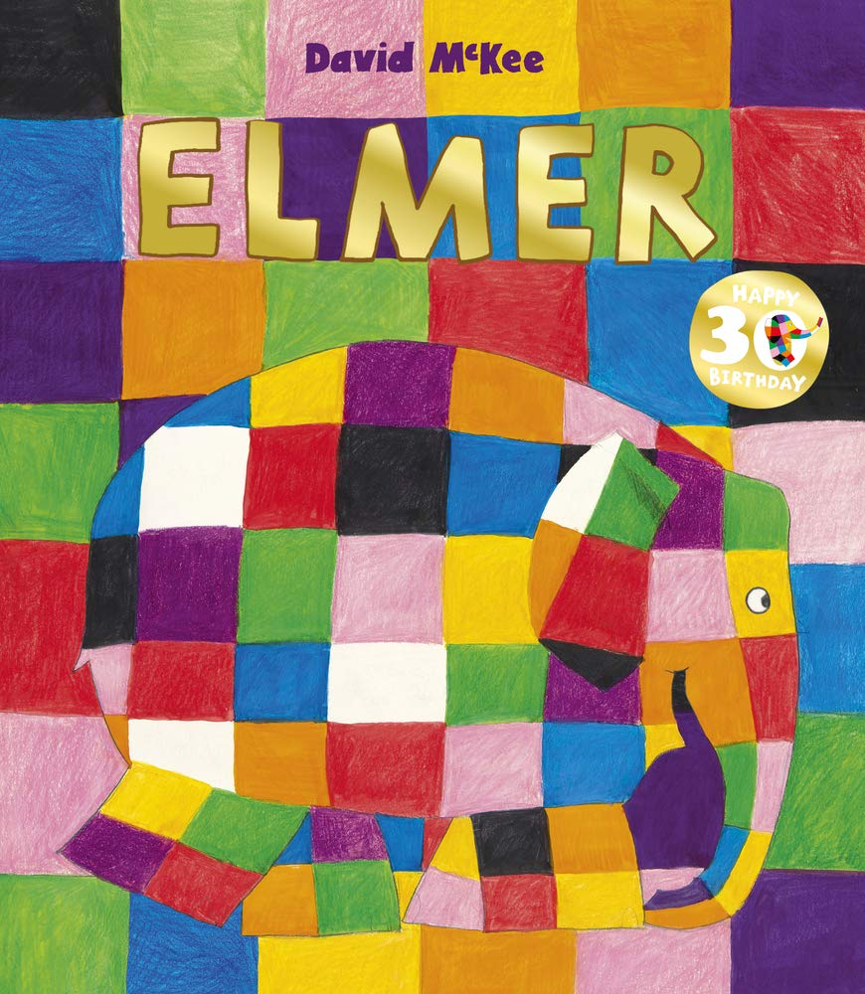 | 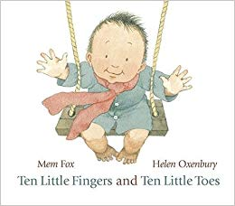
 | I Read/Read to Me: | I Read/Read to Me: | I Read/Read to Me: | I Read/Read to Me: | I Read/Read to Me:
 | Understanding the World | Understanding the World |  | Personal, Social & Emotion Development | Understanding the World
Free Choice | Giraffes Can’t Dance  by Giles Andreae | The Rainbow Fish  by Marcus Pfister | Lost and Found  by Oliver Jeffers | Farmer Duck  by Martin Waddell | Funnybones  by Janet & Allan Ahlberg
 | 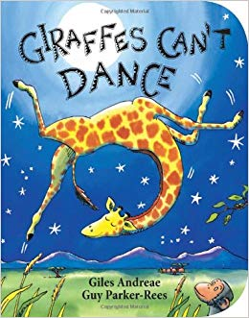 | 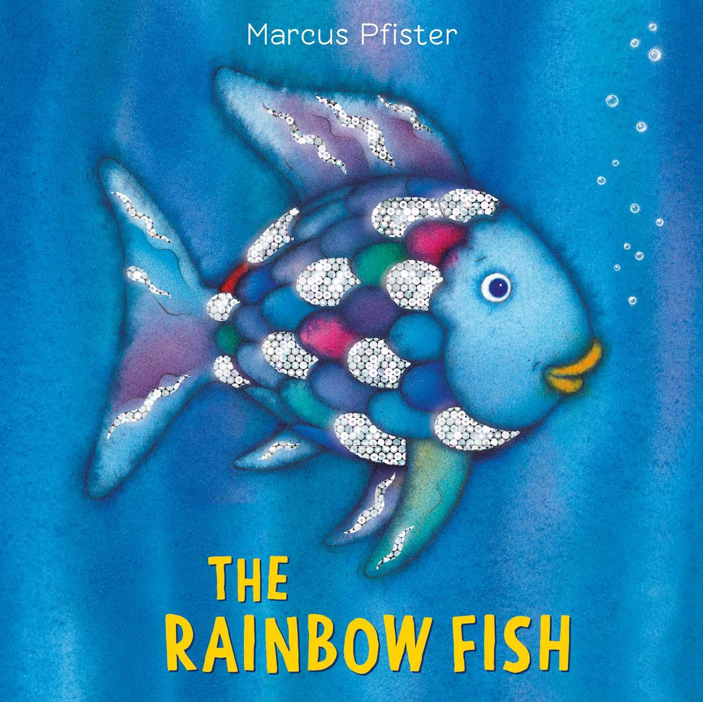 | 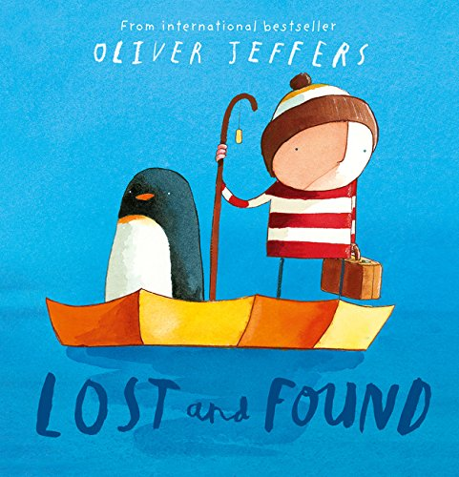 | 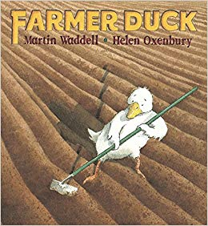 | 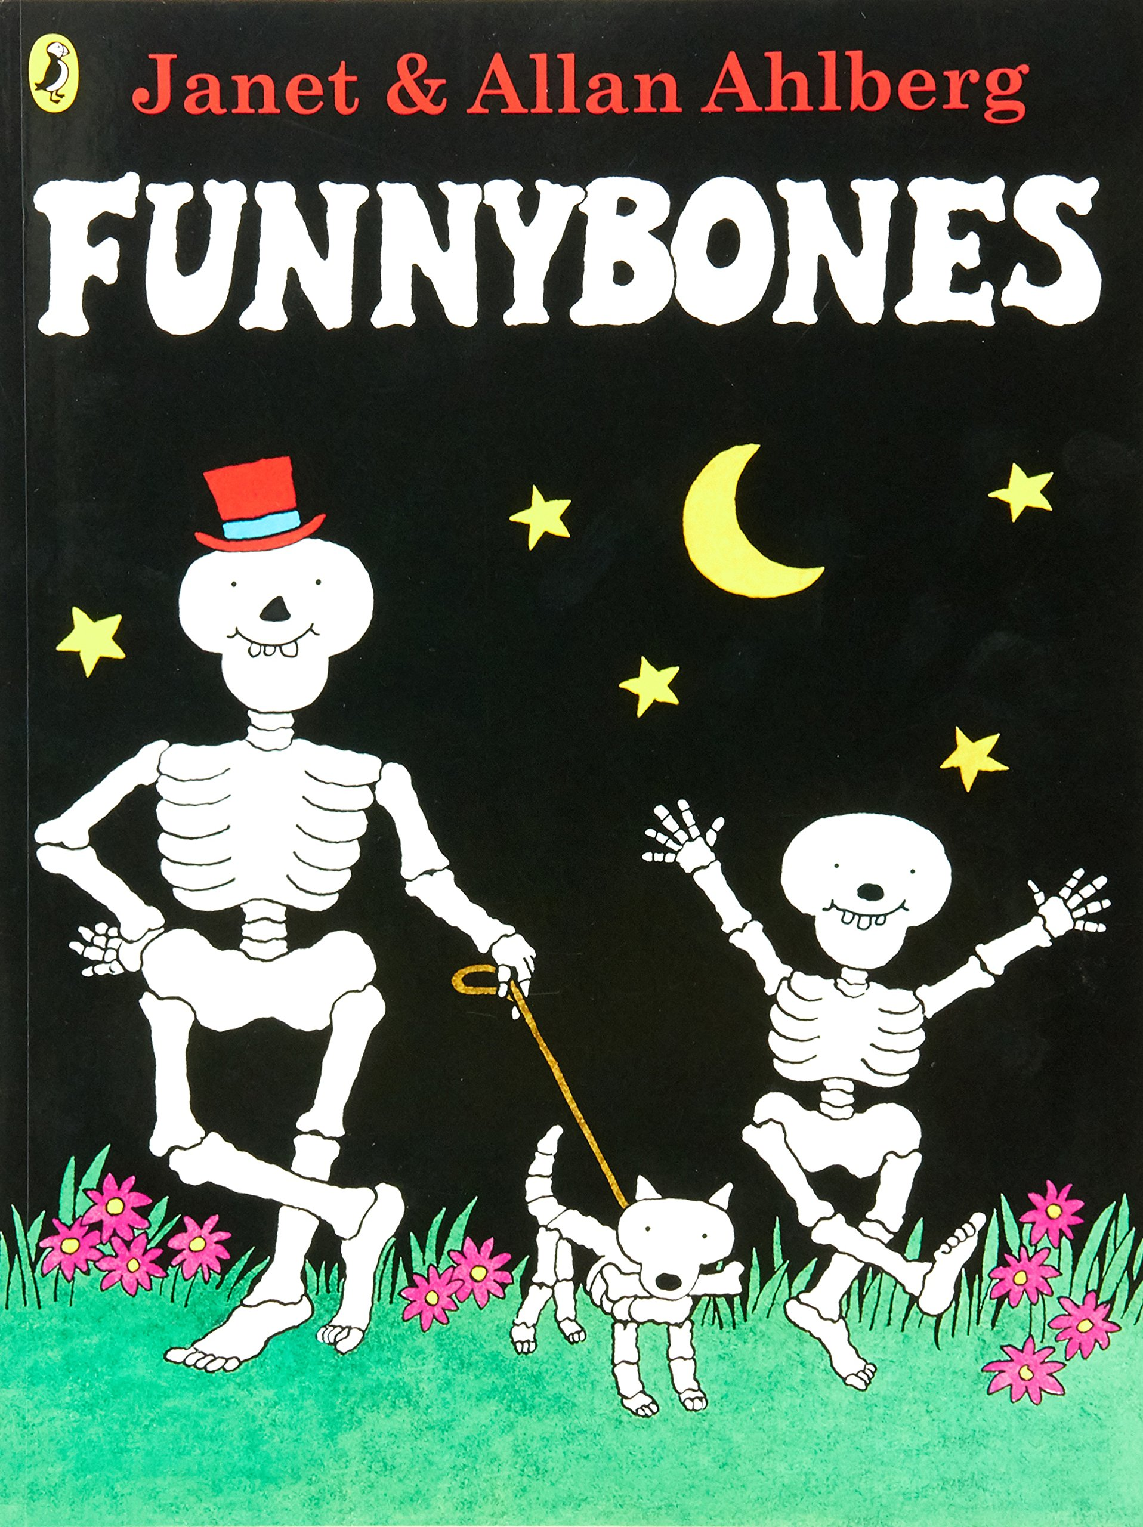
 | I Read/Read to Me: | I Read/Read to Me: | I Read/Read to Me: | I Read/Read to Me: | I Read/Read to Me:
 | Personal, Social & Emotion Development | Personal, Social & Emotion Development
 | Rosie’s Walk  by Pat Hutchins | Whatever Next  by Jill Murphy | Hairy Maclary  by Lynley Dodd | Detective Dog  by Julia Donaldson | Knuffle Bunny  by Mo Willams
 | 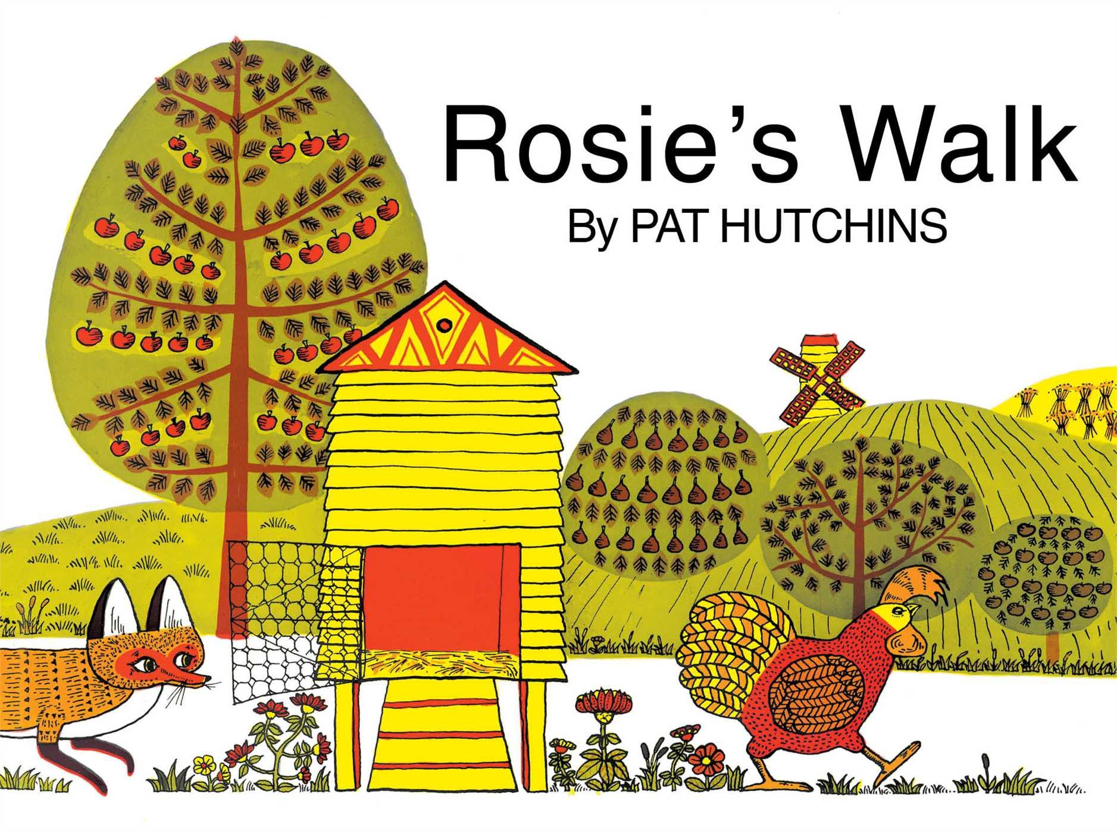 | 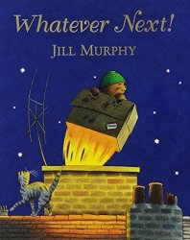 | 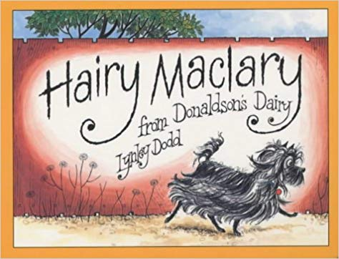 | 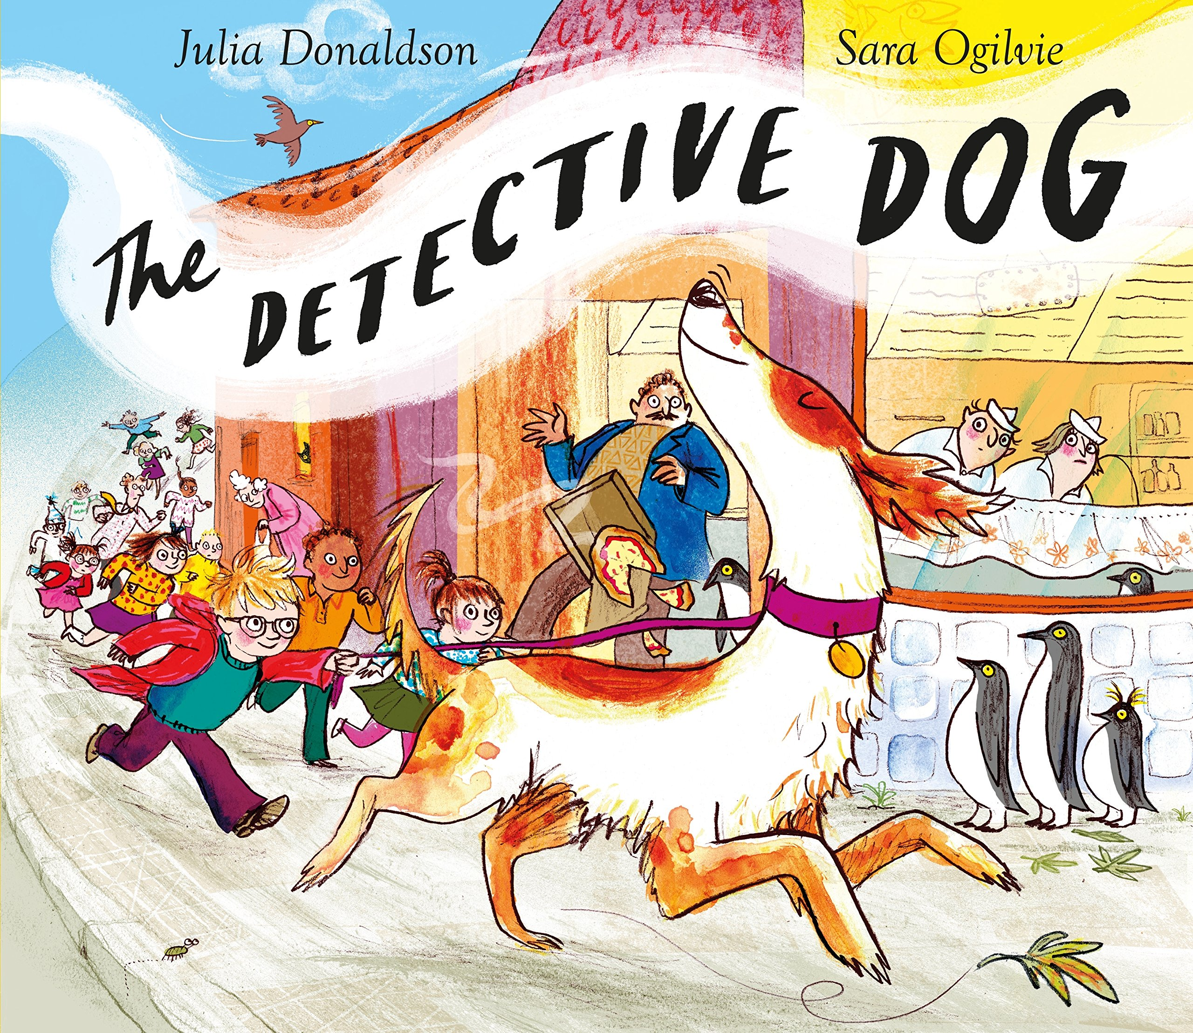 | 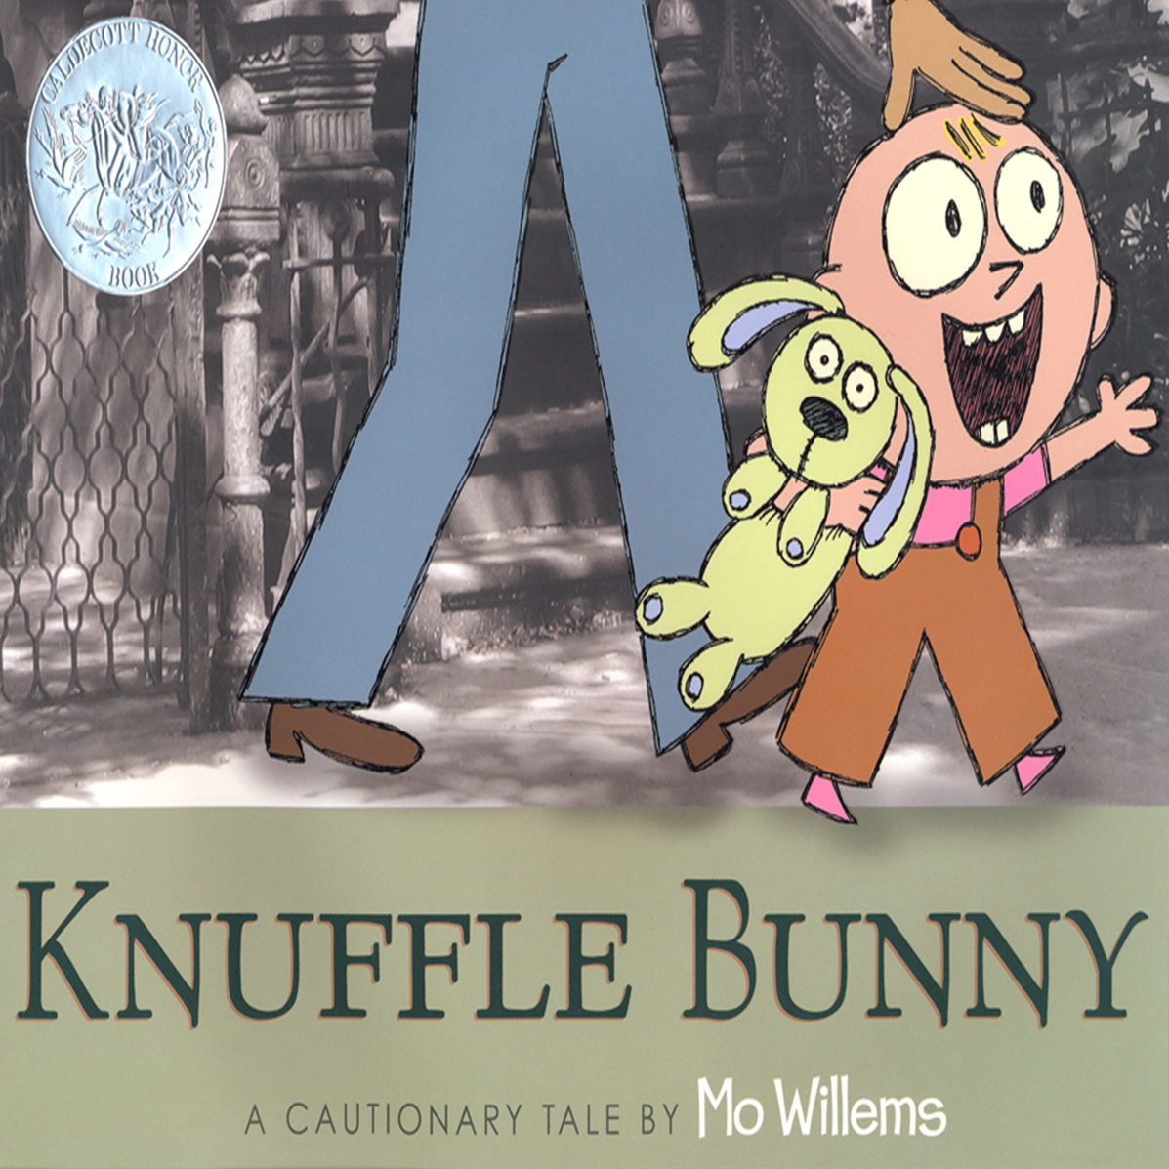
 | I Read/Read to Me: | I Read/Read to Me: | I Read/Read to Me: | I Read/Read to Me: | I Read/Read to Me:
 |  | Expressive Arts and Design

